**Deadline 3 Project EOSC 442**

**Pearl Ayem, Navneet Brar, Thomas Stanford, Nicholas Wu**

**The yearly rate of change of the permafrost active layer thickness between 2009 to 2017 at Owl River in Auyuittuq National Park, Tanquary Fiord in Quttinirpaaq  National Park.**

**Abstract:**

Active layer thickness is the top layer of soil in permafrost that thaws during the summer season and refreezes during winter. The thickness of this layer is affected by the surface temperatures of the locations and is therefore directly related to global climate change.

Research Question:

This research studies whether there is significant difference between active layer thickness (ALT) between Auyuittuq National Park, Tanquary Fiord inQuttinirpaaq  National Park in Nunavut Canada from 2009 to 2017. It also looks at if there is a significant relationship between the ALT and surface temperatures at these locations

Daily air temperature was obtained from the Eureka weather station for Quttinirpaaq and from the Cape Hooper weather station for Auyuittuq. ALT data was obtained from the Parks Canada CALM program. The ALT data was analyzed using a one-way ANOVA test to determine if there is a significant difference between mean rates of change in ALT. The P-value for this test was greater than 0.05 under a  95% confidence interval. Therefore there is no statistical difference between the mean rates of change for ALT of the two locations. The air temperature data was plotted against ALT for both sites.

**Graphs and Results:**

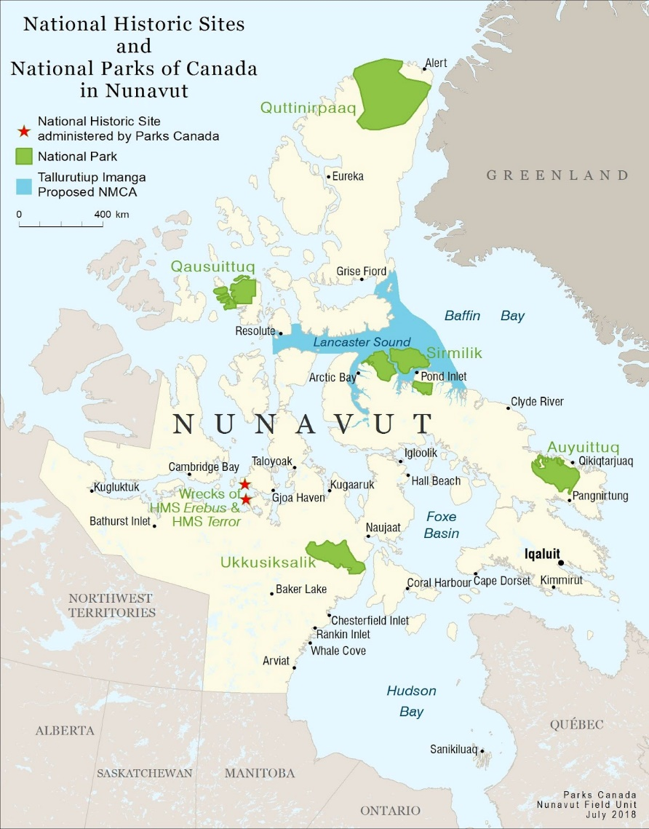

Figure 1: This shows the location of Quttinirpaaq National Park and Auyuittuq National Park

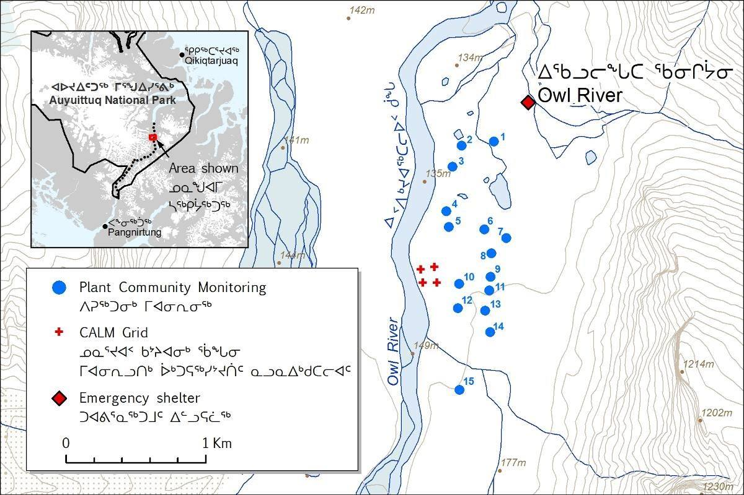

Figure 2: The data at Auyuittuq National Park was collected at Owl River

-The latitude of the Quttinirpaaq National Park is higher than the latitude of Auyuittuq National Park

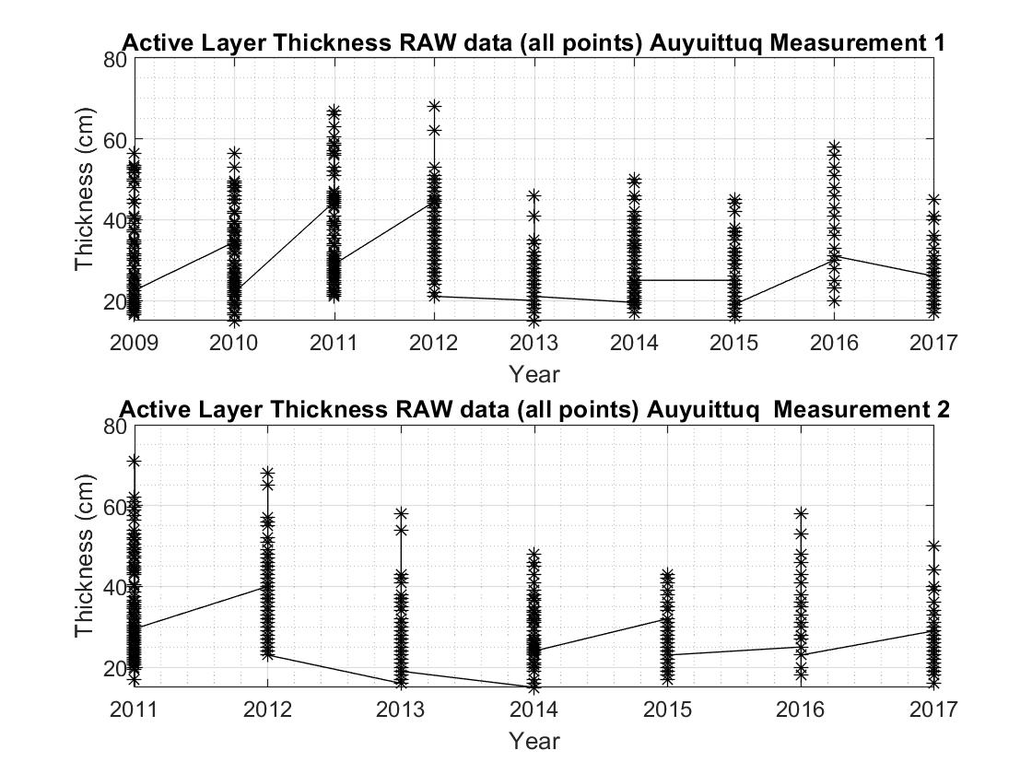

Figure 3: This shows all the data points collected from the 100 grid cells (twice) once per year

-The spread does not reveal much about the nature of the data, thus more analysis needed

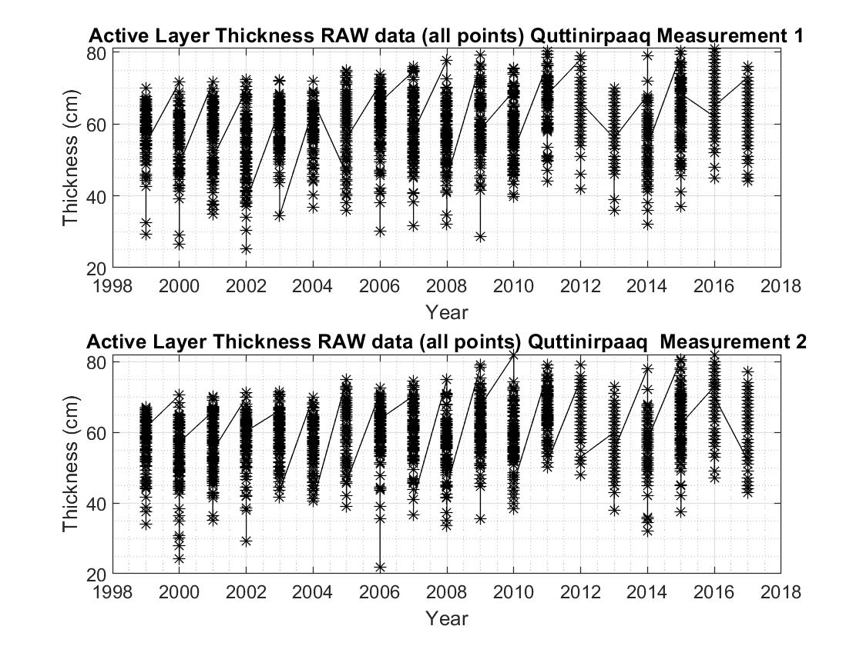

Figure 4: This shows all the data points collected from the 100 grid cells (twice) once per year

-The spread does not reveal much about the nature of the data, and more analysis is needed

-A slight trend showing increasing thickness of the active layer

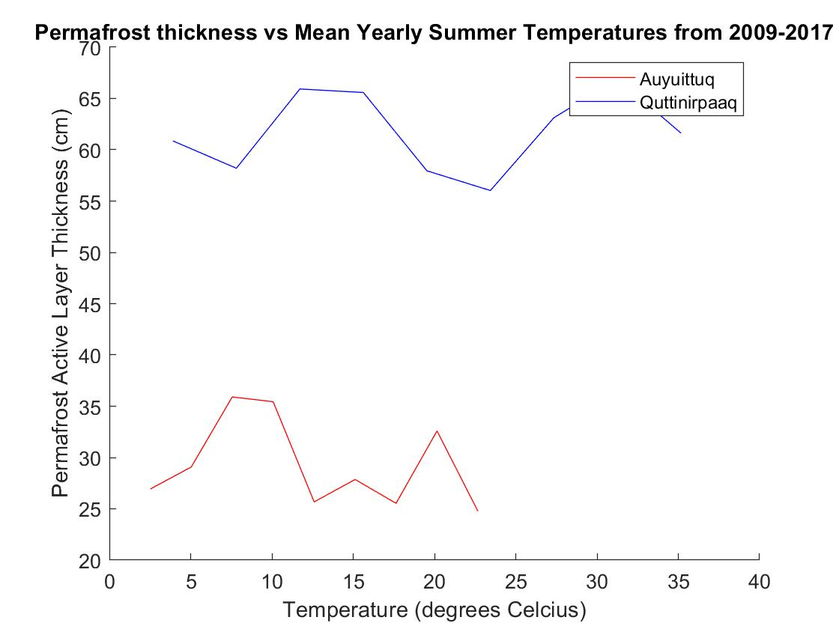

Figure 5: This shows the average permafrost active layer, plotted against the summer mean temperature of the region.

* Both lines show similar shape, and slopes
* The ACT is thicker at the Quttinirpaaq National Park compared to the Auyuittuq National Park

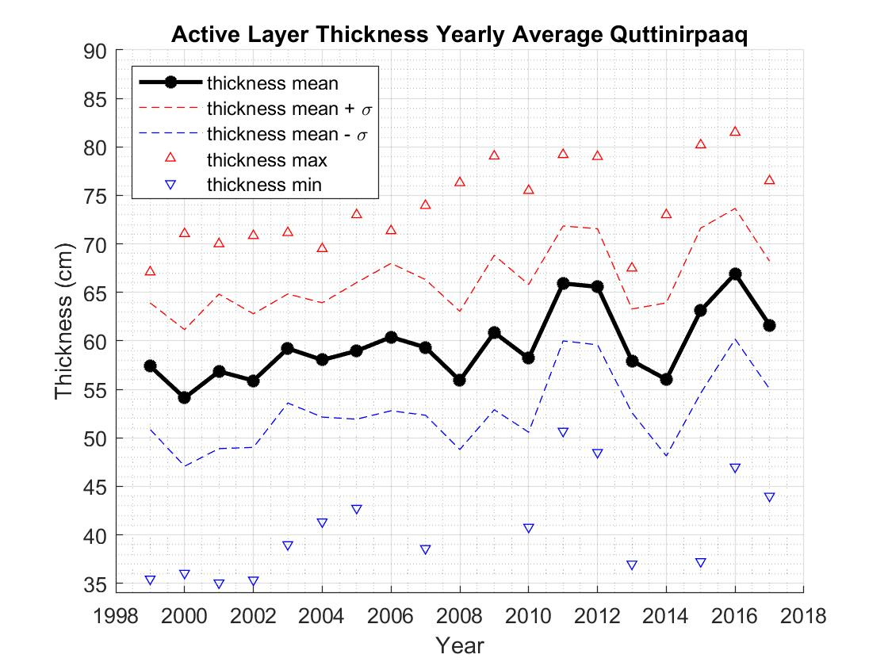

Figure 6: Active layer thickness yearly average at Quttinirpaaq National Park

-Mean temperature curve matches the shape of the permafrost active layer thickness versus temperature curve between 2009 to 2017.

-No fixed increase

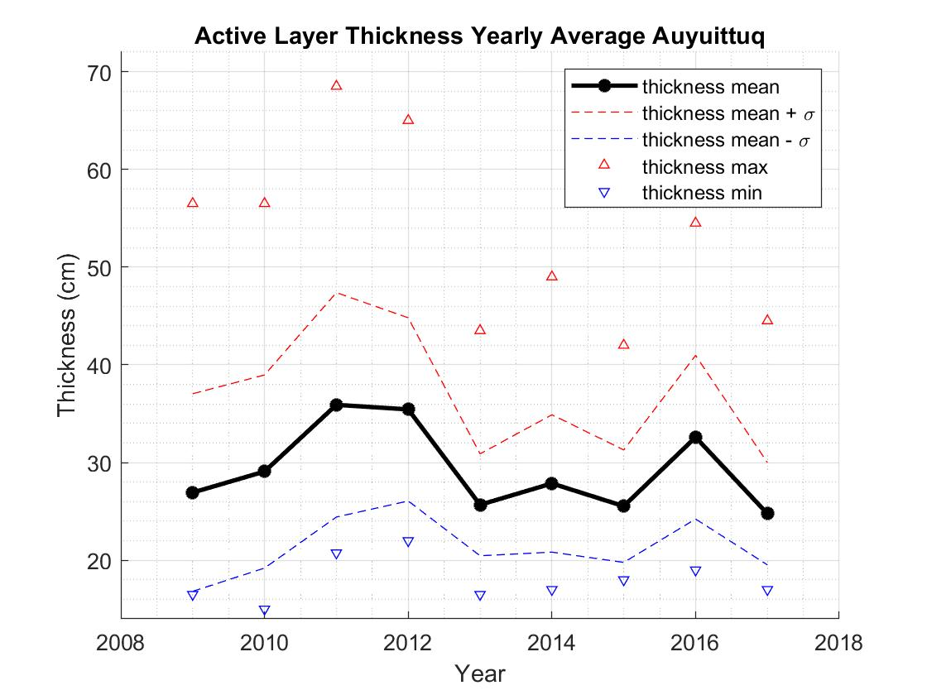

Figure 7: Active layer thickness yearly average at Auyuittuq National Park

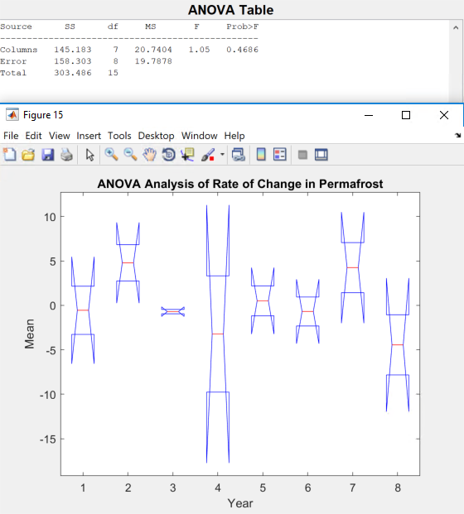

Figure 8: One-Way ANOVA to determine if the mean rate of change in permafrost between both locations had a statistical difference

* We obtained a P-value = 0.4686 and under a 95% confidence interval (α = 0.05), the P-value > α, therefore the mean difference is not statistically significant
* There is not a statistically significant difference in the yearly rates of change of the ACT between Quttinirpaaq National Park and Auyuittuq National Park in 2009-2017.

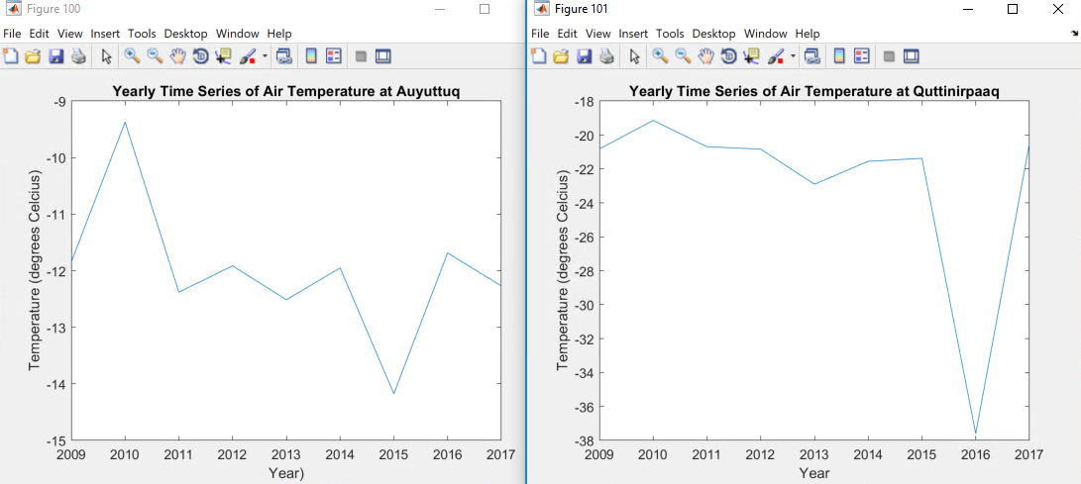

Figure 9: Yearly time series of air temperature at the two locations.

-Yearly average of air temperature at each respective location that will be used to correlate with active layer thickness

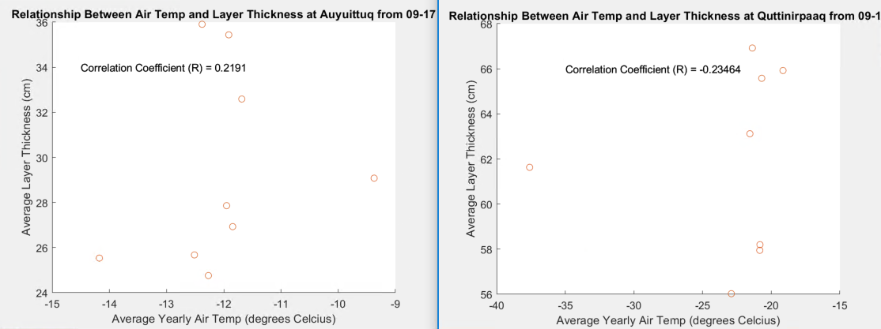

Figure 10: Correlation between air temperature and layer thickness at the 2 locations

-There is no relationship between ALT and surface air temperature at Auyuittuq National Park. The p-value is larger than 0.05 and the R^2 value is 0.2191. There is no significant relationship as the p-value is larger than 0.05 and the R^2 value is very small; thus, many of the data points don’t follow the regression line closely and there are many outliers.

-There is no relationship between ALT and surface air temperature at Quttinirpaaq National Park. The p-value here is also significantly large and the R^2 value is -0.23464. There is no significant relationship as the p-value is larger than 0.05 and the R^2 value is very small; thus, many of the data points don’t follow the regression line closely and there are many outliers.

**Conclusion:**

According to our analysis, there is no significant relationship between ALT and surface air temperature at Quttinirpaaq National Park or Auyuittuq National Park. For Quttinirpaaq National Park, the p-value is very large and the R^2 value is -0.23464. For Auyuittuq National Park, the p-value is very large and the R^2 value is 0.2191. Since both the p-values are larger than 0.05 and the R^2 values were small, we concluded that there is no correlation between ALT and surface air temperature at either location.  Furthermore, the p-value obtained from the one-way ANOVA test was 0.4686. Since this is larger than 0.05, we can conclude that there is not a statistically significant difference in the yearly rates of change of the ALT between Quttinirpaaq National Park and Auyuittuq National Park in 2009-2017.